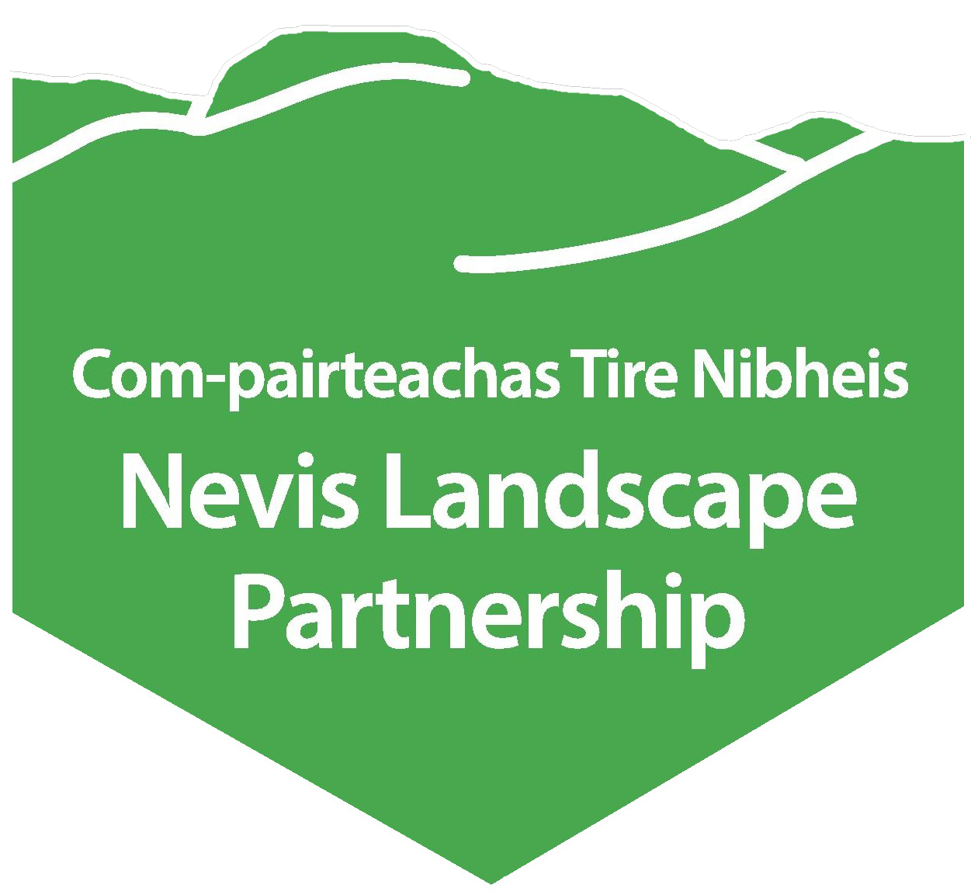 | APPLICATION FORM  POSITION APPLIED FOR:  CLOSING DATE: Friday 5th May @ 10.00am

PERSONAL DETAILS
Full Name
Address
Telephone Number
Email Address

Nationality
Are you free to remain and take up employment in the UK with no current immigration restrictions? | Yes | No
If no, please provide details of work visa/permit including expiry date.
Where did you hear about this vacancy?

PERSONAL STATEMENT
Please tell us briefly why you are applying for this position and how you could contribute to our work? (300 words maximum)

PERSON SPECIFICATION
The successful candidate should be able to demonstrate that they have most of the following skills, experience or knowledge. Referring to the job description, please provide examples of how you meet the criteria. (150 words maximum per section)
Experience of working in a popular visitor destination and thorough knowledge of the Scottish Outdoor Access Code.

A commitment to the conservation of our environment and wild lands, with practical skills.

Good interpersonal and communication skills, showing a willingness to work with a wide range of people, to encourage and raise awareness of our environment.
Willingness/experience of working as a team however showing initiative to work independently. Confidence to contribute ideas into the projects.
Knowledge and experience of mountain environments.

Reasonable level of fitness required and willingness to work in mountain/outdoor environments in inclement weather.
If you are applying for the Lead Ranger post, please tell us about your experience leading a team and planning work rotas.

Skills / qualifications | Yes | No | Expiry Date / Comments
First Aid Qualification
Full, valid driving licence
D1 classification on driving licence to be able to drive the minibus
D1+E classification on driving licence to use a trailer
Do you have any charges pending that may affect your licence?
IT Skills – Microsoft, Word, Excel, Power Point, Outlook
EMPLOYMENT / VOLUNTEERING
Please tell us about any employment or volunteering you have undertaken which is relevant to this post.
Dates From – To | Employers Name | Position Held | Reasons for Leaving

IN RELATION TO YOUR EMPLOYEMENT / VOLUNTEERING STATED ABOVE, PLEASE SUMMARISE KEY RESPONSIBILITIES RELEVANT TO THESE ROLES (150 words maximum)

EDUCATION, RELEVANT TRAINING & QUALIFICATIONS
Name of Education Establishment | Subject | Level/Title of Examination | Grade Achieved | Date of Achievement

MEMBERSHIP OF RELEVANT PROFESSIONAL ASSOCIATIONS

APPLICATION PROCESS
Candidates are invited to apply via this application form.
Applications should be sent to Rory Stewart, Nevis Landscape Partnership Manager, and emailed to
rory@nevislandscape.co.uk
Please note the closing date given above. Late submissions will not be considered.
Please note the interview date given in the Job Description and ensure you would be free to attend if invited.

DATA PROTECTION ACT
The personal information collected on this form will only be used for the purposes of recruitment and selection for the post you have applied for with the Nevis Partnership. The information will not be used for any other purpose, nor will it be disclosed to any third party.

DECLARATION
The details on this application form are correct to the best of my knowledge. I understand that if my application is subsequently discovered to be false or misleading, or that I have withheld relevant information, my application will be disqualified or, if I have already been appointed, I may be dismissed.

Signature: Date:

